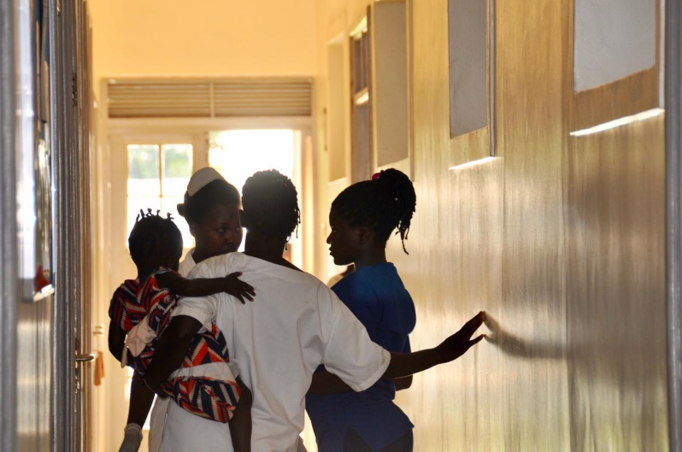
The Hospital receives about £50,000 from the government each year which goes towards looking after the 600,000 people in Kamuli area, a number continuously rising (about 16 million in 1988 and now 45 million!). This is not a huge sum in the big scheme of things, but if it were to be withdrawn, the hospital would really struggle. The rest of the hospital income comes from charity, foreign aid and a small contribution from patients at the time of treatment. The income flow is fairly precarious, making hospital managers nervous to spend or borrow money to secure the hospital’s future.
This year, I stepped back from some of the clinical work and focused more on the future for the hospital. I have had several meetings with the medical superintendent Dr. Andrew Muleledhu and met the hospital board to discuss the sustainability of the hospital and ways of diversification.

Kamulifriends has continued to flourish throughout 2018 with a continuous stream of volunteers and hard-working clinical treatment camps

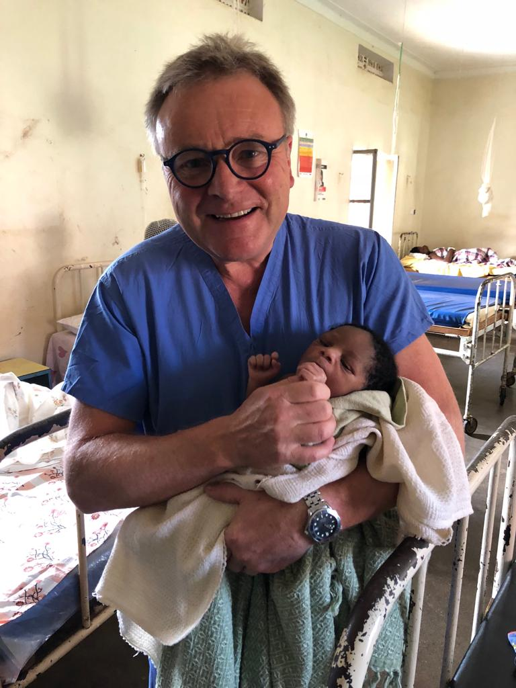
Diversification can be risky, as we would be dipping our collective toes into unknown territory, attempting new projects of which we have little knowledge.
Let me go through some of our ideas first.
The hospital has about 150 acres of land available which could be used to grow sugar cane and generate additional income. I also proposed we set up eye and dental services, entertaining the possibility of having private clinics within the hospital buildings. Finally, our murals, on strategic walls around the hospital, have been a great success and lifted the spirits of everyone passing by! The power of art! With that in mind, I was thinking of creating a community arts facility in one of the unused buildings where the local community could work, have workshops and form a sculpture garden. I explained my ideas to the hospital board hoping that it would increase the visibility and appeal of Kamuli. I might have gone a step too far with the art idea!
This year we have not undertaken any major construction works as we were saving money to rebuild the doctor’s accommodation (about £200,000). We are about a third the way there. We are helping some individual cases as usual which is a bit of an indulgence for me, I have to admit.

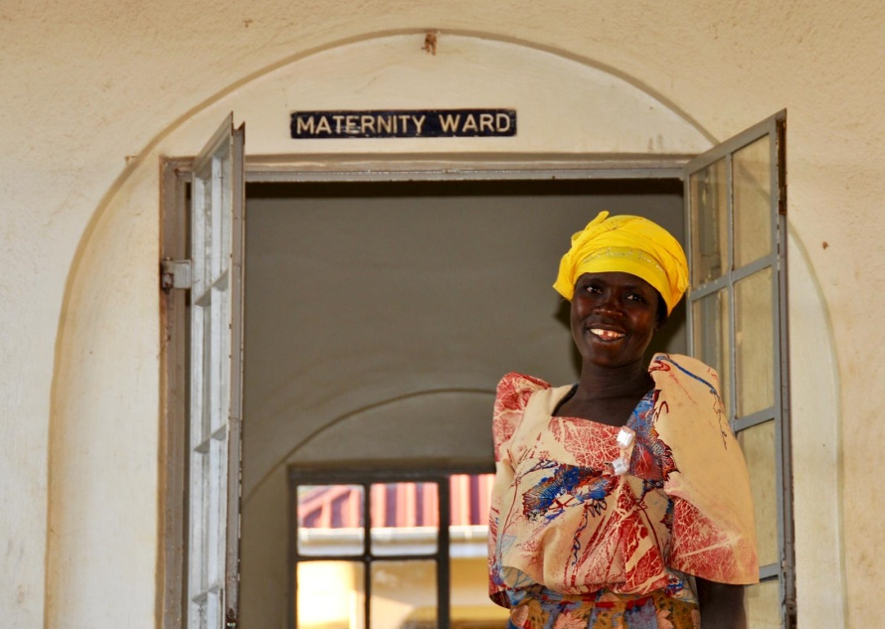
The volunteer programme is always very active and extremely busy. This year, during the last two weeks, we have had volunteers from Australia, Belgium, Iran and Sweden. We welcome medical and gap-year students, nurses and doctors. Alice coordinates this brilliantly. There is a lovely sense of support and friendship within the guesthouse and I think everyone enjoys their stay and gets something from it. We also had two non-medical volunteers, Yacintha and Farnoosh, who helped out teaching in the local St. Theresa School, which is next door to the hospital. I believe they have found this to be a very rewarding experience.
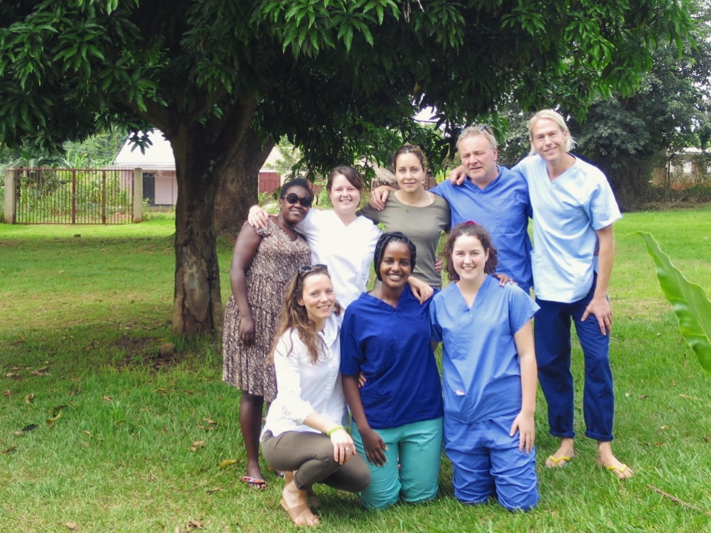
We will try to do a final event in Spring to make it to the finishing line on this last big capital expenditure. As always, I thank you for your generosity and showing interest. Of course, I would also like to thank Trudie, who does so much from an administration point of view, and our very kind but cautious Trustees.

I hope you have a Happy Christmas!

Philip

