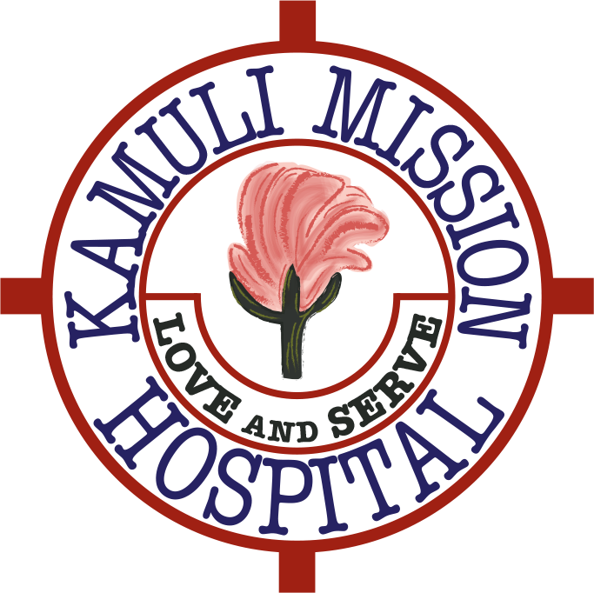
KamuliFriends Newsletter
December 2015

Dear Friends and Supporters

Welcome to our second Newsletter.

Our main focus this year has been to push forward with the building and completion of the Junior, Senior Staff Houses and the Guest House. This has involved a lot of work and expense but thanks to your generosity I am pleased to say that in the last couple of months they are now fully functional. The proceeds of our party at the Shooting Lodge in Moulsford last May and a fundraising ball at Queen Anne’s School funded the Staff Houses and a very generous donation from the Mosawi Foundation enabled us to build the Guest House. The staff now have accommodation that is purpose built with fully functional washing facilities. The Guest House is now also more comfortable for visiting doctors, students etc and we and the staff are extremely grateful.
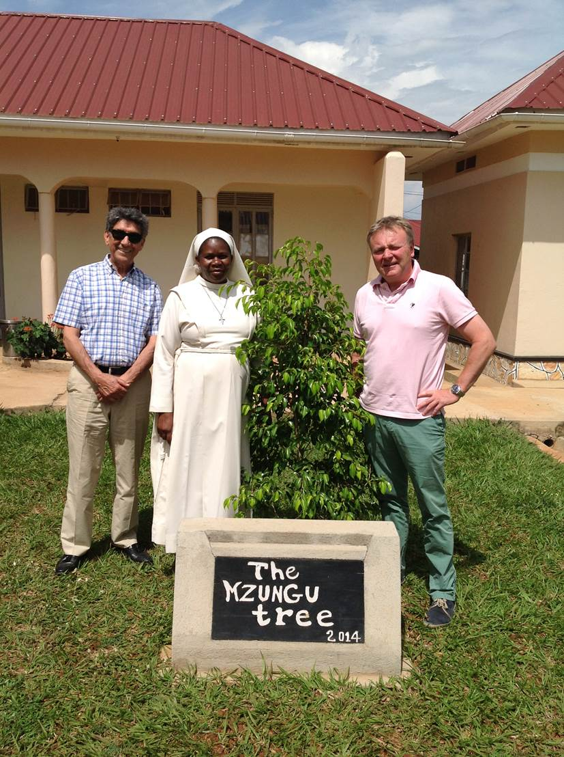

Ali Mosawi and Philip Unwin with one of the Sisters outside one of the completed Staff Houses
Over the last few years it has become apparent that an ambulance, to help with transporting patients to the hospital, would be greatly beneficial. The hospital serves a population of over 750,000 people in the Kamuli district. Mothers may have to travel vast distances on treacherous roads to access maternity services. It is not uncommon for women who live in rural areas, to make these journeys with life threatening complications of pregnancy, such as a ruptured uterus with extensive blood loss, by bus. In addition to maternal deaths, the fetal outcomes in these situations are often not good. We are constantly working to improve the outcome for mothers and babies in the Kamuli district. As part of the antenatal education the need to get into hospital in a timely fashion in emphasised and providing that transport is essential. Dr Alice Unwin (Philip’s niece) decided to spearhead a campaign to raise funds to purchase an ambulance. At the beginning of the year Alice had a clothes swap day and then at the beginning of the summer put together a music festival (“KamuliFest”) near her home in Gloucestershire. In June of this year Philip and three of his friends, Robert Clive, Paddy Burrowes and Steve Kendall undertook to play 108 holes of golf in a day at Huntercombe Golf Day. It was a blazing hot day but all four managed to complete the challenge. We had many generous sponsors and the Golf Day together with the proceeds from KamuliFest and Alice’s clothes swap day raised over £32,500 towards the purchase and running costs of an ambulance. Currently we are doing due diligence in terms of the type we should buy and we hope this will be up and running in 2016.

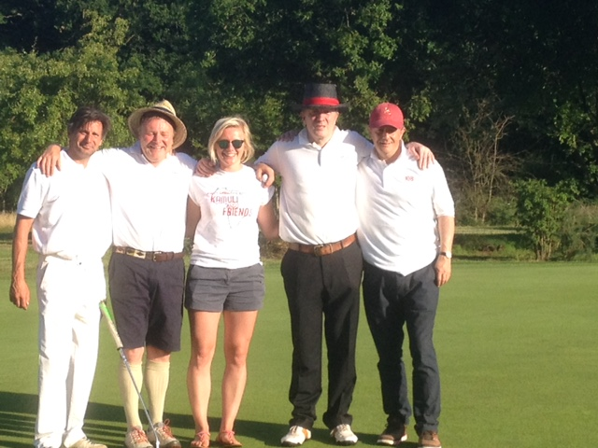
Golf Day with (left to right) Steve Kendall, Philip Unwin, Alice Unwin, Paddy Burrowes and Robert Clive.
Alice has been working hard on the volunteer programme as well as coordinating the Ambulance Project. She is working on setting up an induction programme for volunteers. Several groups of doctors have visited this year. Two of them Dr Patrick Barker and Dr Clare Roberts have implemented a triage system in the emergency room which has made a huge difference.

Philip visited in September and in November this year. The November trip was for two weeks and he worked with Dr Fred Lohmander in theatre and also reviewed the works undertaken so far. Ellie Mosawi also visited providing invaluable support. Philip, with the approval of the Trustees, has commissioned a local artist to paint some murals in the wards to brighten the place up. Collin Sekajugo a local artist with an international reputation will work with volunteers to do this. You can view Collin’s work on this website (www.devearts.com/colin-sekajugo.html) here. I hope you agree this will be money well spent.

The other exciting project that Philip has been working on is establishing a link with the solar industry. Most of the electricity currently supplying the hospital comes from a large state owned generating plant situated at a huge dam on the Nile at Jinja. The hospital’s needs in terms of requiring electricity are not great as they cannot afford expensive electrical medical equipment. There is one air conditioning unit in theatre, which you do need – you wear rubber aprons with double gowns due to the risk of infection and it is very hot. Power cuts occur all the time either due to the hospital not being able to pay the bill or due to the supply ‘going down’. When Philip visited in 2014 10 days out of the 14 he was there they had no power at all. At night time operations are carried out using mobile ‘phone torches and head torches.

Philip presented at the National Power Awards ceremony in September at the NEC in Birmingham with Leo Johnson (brother of Boris) as compere, where Philip managed to persuade them to donate all he solar equipment needed to solar power the hospital. We will let you know in due course how this progresses.

You have all been so generous this year and in total we have managed to raise xxxxxxxxxxxxx in fundraising events and pledges.

We have achieved an enormous amount this year due to your generosity but there is still a long way to go. In an ideal world we would like to start rebuilding the paediatric and medical wards but we have to ensure we have enough funds in the bank before we can start these.

We have put together a video which shows the progress that has been made so far and you can watch it via the following You Tube link here https://www.youtube.com/watch?v=CirXI0puKdA.

With all best wishes for a happy and healthy 2016.

Philip, Alice, Fred, Steve, Trevor, Helen and Trudie
KamuliFriends
http://www.kamulifriends.com/
Registered Charity No1155812
Just Giving link (http://www.kamulifriends.com/donate/) click here
